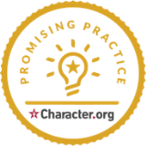**For Immediate Release  
Contact: Nicole Diehl  
Coordinator, Missouri Schools of Character**[**ndiehl@characterplus.org**](mailto:ndiehl@characterplus.org)[**http://characterplus.org**](http://characterplus.org)

**CharacterPlus® Celebrates Missouri Schools Receiving 2024 Promising Practice Recognition**

**(June 14, 2024) St. Louis, MO…** CharacterPlus®, the longest-running character education initiative in the country, is

proud to announce Missouri’s 28 schools and three districts named 2024 Promising Practice Schools and Districts of Character. Nationally, 199 schools and school districts received the honor this year.

Each of these Promising Practice programs and initiatives demonstrate significant impact and strongly aligns with one or more of Character.org’s *11 Principles* that help schools and organizations to intentionally cultivate a culture of character. These exemplary practices include peer mentoring, service-learning, and character-affirming approaches to conflict resolution.

One of the highlights of our year at CharacterPlus is recognizing the hard work and dedication of these schools. This year Missouri and New Jersey lead the nation in Promising Practice schools as a percentage of each state’s total school population. Missouri schools and school districts include:

Barretts Elementary

Bayless Elementary

Bayless School District

Betty Wheeler CJA

Claude Brown Elementary

Don Earl Early Childhood Center

Dunklin R-5

Frontier STEM High School

Hawk Point Elementary

Kentucky Trail Elementary

Ladue Early Childhood Center

Lindbergh High School

Mason School of Academic and Cultural Literacy

Mill Creek Upper Elementary

Nance Elementary

Nike Elementary

Northeast Middle School

Oak Brook Elementary School

Parkway Early Childhood

Parkway West High School

River Bend Elementary

Riverbend Middle School

Robertsville Elementary

Ross Elementary

School District of Washington

Spoede Elementary School

Truman Elementary

Truman Middle School

Wilckens STEAM Academy at Hillcrest

Wildwood Middle School

Zitzman Elementary

Zitzman Elementary

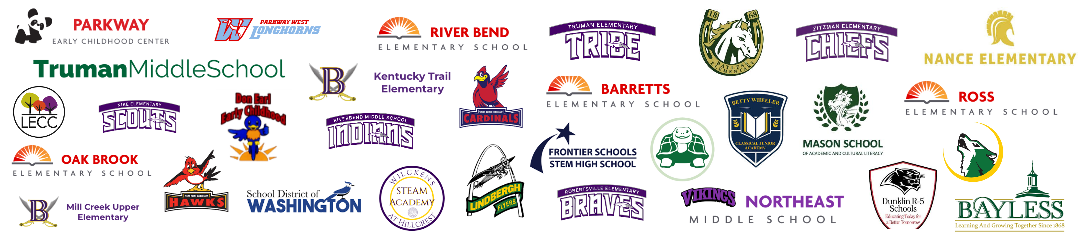

CharacterPlus, located in St. Louis, is a partnership-based nonprofit organization committed to equipping school stakeholders with the resources they need to provide high quality character education. Through CharacterPlus, schools receive evidence-based development and training in effective character education for school transformation.

*The 11 Principles of Character Education* and State Schools of Character are trademarks of [Character.org](https://www.character.org/) in Washington, DC. Character.org and CharacterPlus have been partners in character education since 1993.

For additional information about this recognition or each school’s journey to State or National School of Character designation, please contact Nicole Diehl, Missouri Schools of Character Coordinator, at [ndiehl@characterplus.org,](mailto:ndiehl@characterplus.org) or visit us at [characterplus.org.](https://www.characterplus.org/)

Schools of Character is generously supported by:

](https://poettkerconstruction.com/)

Learn more at [poettkerconstruction.com](https://poettkerconstruction.com/)

###